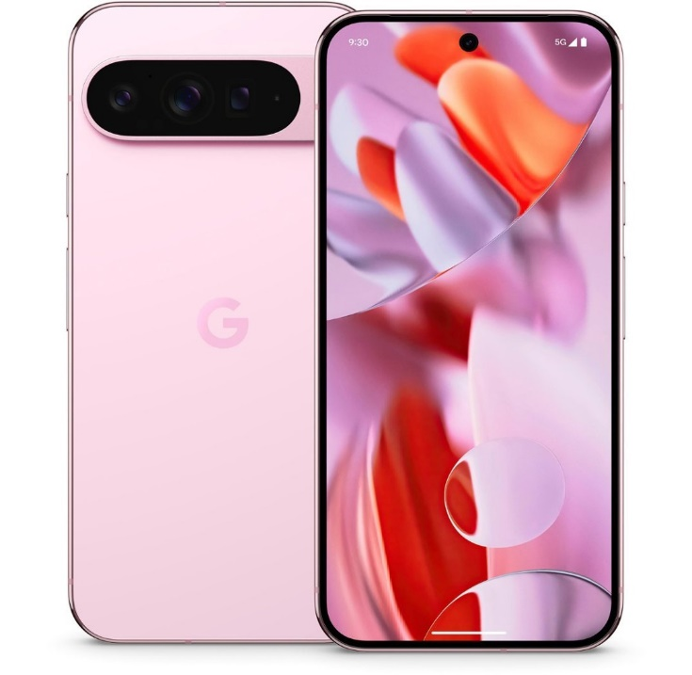

Google pexel 9 pro

All pro.
Pure magic.
It’s the most powerful Pixel yet, with Gemini, your built-in AI assistant.¹
$41.62/mo $31.21/mo Save $250
0% financing available *
Retail price: $999 $749

Display
6.3-inch Super Actua Display (LTPO)¹
20:9 aspect ratio
1280 x 2856 LTPO OLED at 495 PPI
Smooth Display (1–120 Hz)²
Corning® Gorilla® Glass Victus® 2 cover glass

Up to 2,000 nits (HDR) and up to 3,000 nits (peak brightness)³
>2,000,000:1 contrast ratio
HDR support
Full 24-bit depth for 16 million colours

Dimensions and Weight⁴
152.8 mm (height) x 72 mm (width) x 8.5 mm (depth)
199 g

Battery and Charging
24+ hour battery life⁵
Up to 100-hour battery life with Extreme Battery Saver⁶
Typical 4,700 mAh (Minimum 4,558 mAh)⁷
Fast charging – up to 55% in about 30 minutes – using Google 45 W USB-C® charger, sold separately⁸
Fast wireless charging (Qi-certified)⁹
Battery Share¹⁰

Memory and Storage
16 GB RAM
128 GB¹¹
256 GB¹²
512 GB¹³
1 TB¹⁴

Processor
Google Tensor G4
Titan M2 security coprocessor

Security
Google VPN at no extra cost¹⁵
End-to-end security designed by Google
Multi-layer hardware security: Tensor security core, certified Titan M2 security chip and Trusty (Trusted Execution Environment)
Anti-malware and anti-phishing protection
Spam protection in Google Phone and Messages
Learn more at g.co/pixel/security and g.co/pixel/certifications

Tele camera
48 MP Quad PD telephoto camera
ƒ/2.8 aperture
22° field of view¹⁹
5x optical zoom
Super Res Zoom up to 30x²⁰
1/2.55" image sensor size

All Rear Cameras
Multi-zone LDAF (laser detect auto-focus) sensor
Spectral and flicker sensor
Optical + electronic image stabilisation on wide and telephoto

Rear Camera
8K video recording at 30 FPS (powered by Video Boost)
4K video recording at 24/30/60 FPS
1080p video recording at 24/30/60 FPS
Dual exposure on wide camera³¹
Super Res Zoom Video up to 20x³²

Front Camera
4K video recording at 30/60 FPS

Video Features
Video Boost
Night Sight Video
Super Res Zoom Video³³
Audio Magic Eraser³⁴
Macro Focus Video
10-bit HDR video
Cinematic Blur
Cinematic Pan
Slo-mo video support up to 240 FPS
4K timelapse with stabilisation
Astrophotography timelapse
Night Sight timelapse
Optical image stabilisation for video
Fused video stabilisation
Cinematic Pan video stabilisation (4K, 1080p)
Locked video stabilisation (4K, 1080p)
Active video stabilisation (1080p)
Video formats: HEVC (H.265), AVC (H.264)

Audio
Stereo recording
Speech enhancement
Wind noise reduction
Audio zoom

Google AI
Gemini Nano
Gemini, your built-in AI assistant³⁵
Gemini Live³⁶
Gemini Apps³⁷

Materials and durability
Scratch-resistant Corning® Gorilla® Glass Victus® 2 cover glass
Corning® Gorilla® Glass Victus® 2 polished back with satin finish metal frame
IP68 dust and water resistance³⁸
Fingerprint-resistant coating
The aluminium in the housing is 100% recycled content³⁹
Made with at least 18% recycled materials based on product weight
100% plastic-free packaging⁴⁰

Google AI
Gemini Nano
Gemini, your built-in AI assistant³⁵
Gemini Live³⁶
Gemini Apps³⁷

Materials and durability
Scratch-resistant Corning® Gorilla® Glass Victus® 2 cover glass
Corning® Gorilla® Glass Victus® 2 polished back with satin finish metal frame
IP68 dust and water resistance³⁸
Fingerprint-resistant coating
The aluminium in the housing is 100% recycled content³⁹
Made with at least 18% recycled materials based on product weight
100% plastic-free packaging⁴⁰

Security and OS updates
Seven years of OS, security and Pixel Drop updates⁴¹

Operating System
Launched with Android 14

Authentication
Fingerprint Unlock
Face Unlock
Pattern, PIN, password

Safety
Emergency SOS⁴²
Crisis Alerts⁴³
Car Crash Detection⁴⁴
Safety Check⁴⁵
Emergency Location Service⁴⁶
Emergency contacts and medical info⁴⁷
Android Earthquake Alerts System⁴⁸

Sensors
Proximity sensor
Ambient light sensor
Accelerometer
Gyrometer
Magnetometer
Barometer
Temperature sensor

SIMs
Dual SIM (Single Nano SIM and eSIM)⁴⁹

Connectivity and Location
Wi-Fi 7 (802.11be) with 2.4GHz+5GHz+6GHz, 2x2+2x2 MIMO
Bluetooth® v5.3 with dual antennas for enhanced quality and connection
NFC
Google Cast
Ultra-wideband chip for accurate ranging and spatial orientation⁵¹
Dual Band GNSS
GPS, GLONASS, Galileo, Beidou, QZSS, NavIC

Network⁵²
5G Sub 6 GHz Model GEC77⁵³
GSM/EDGE: Quad-band (850, 900, 1,800, 1,900 MHz)
UMTS/HSPA+/HSDPA: Bands 1,2,4,5,6,8,19
LTE: Bands B1/2/3/4/5/7/8/12/13/14/17/18/19/20/21/25/26/28/29/30/32/38/39/40/41/42/48/66/71/75
5G sub-6: Bands n1/2/3/5/7/8/12/14/20/25/26/28/30/38/40/41/66/71/75/76/77/78/79⁵⁴
eSIM

Accessibility
Hearing-aid compatible per FCC requirements. Conversational gain: 17 dB w/ aid and 18 dB w/o aid (DA 23-914). See g.co/pixel/hac.
Guided Frame
Magnifier
Live Caption
Live Transcribe & Sound Notifications
TalkBack screen reader
Lookout
Reading Mode
Sound Amplifier & Conversation mode
Camera Switches
Voice Access
Real-time text

Warranty
2 years

